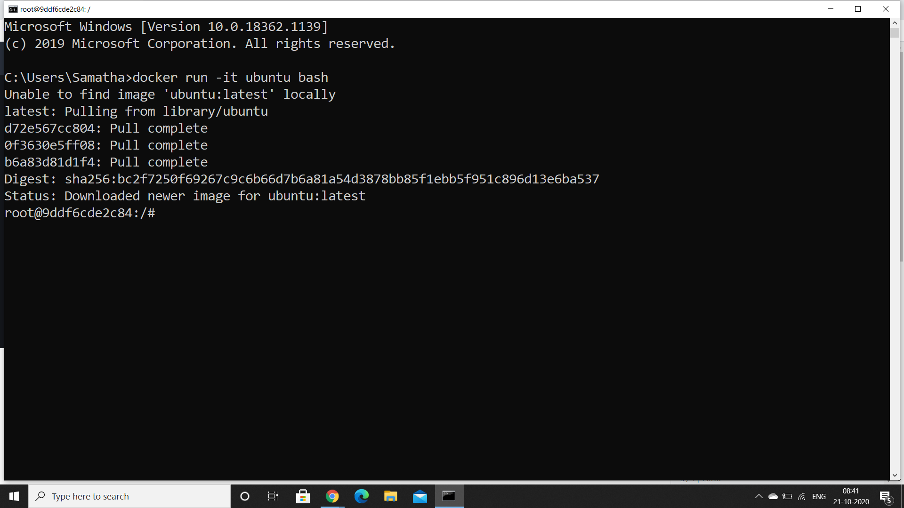

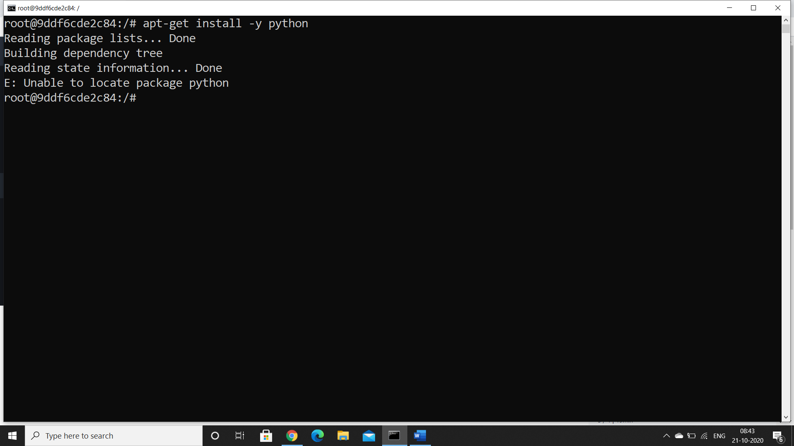

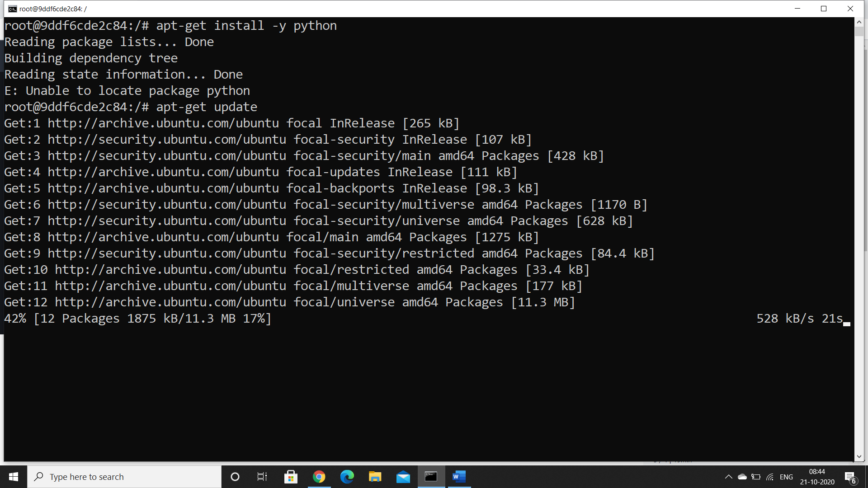

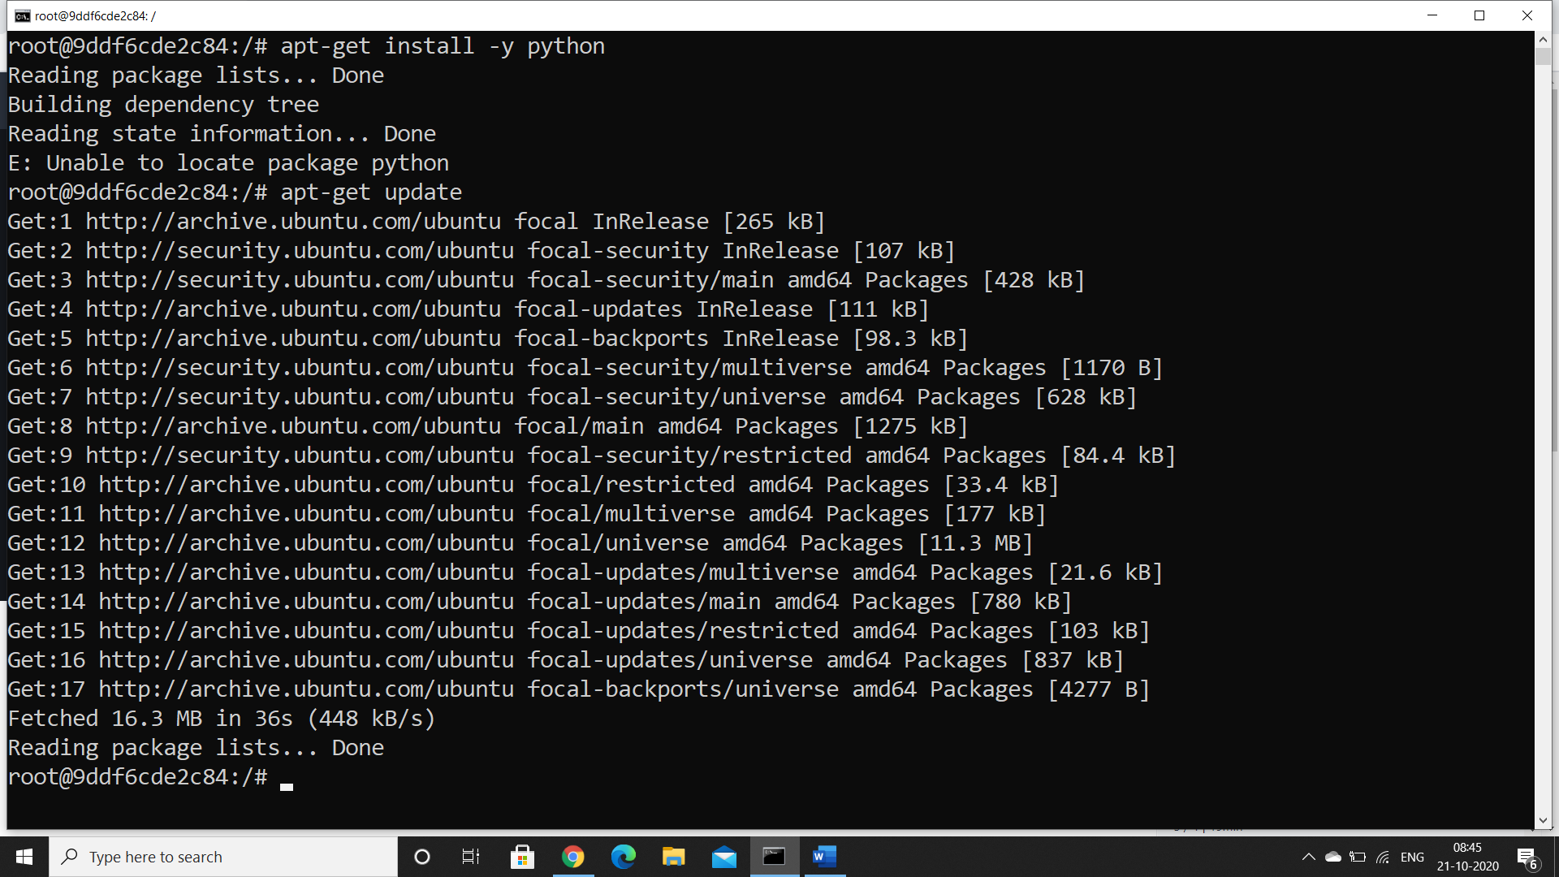

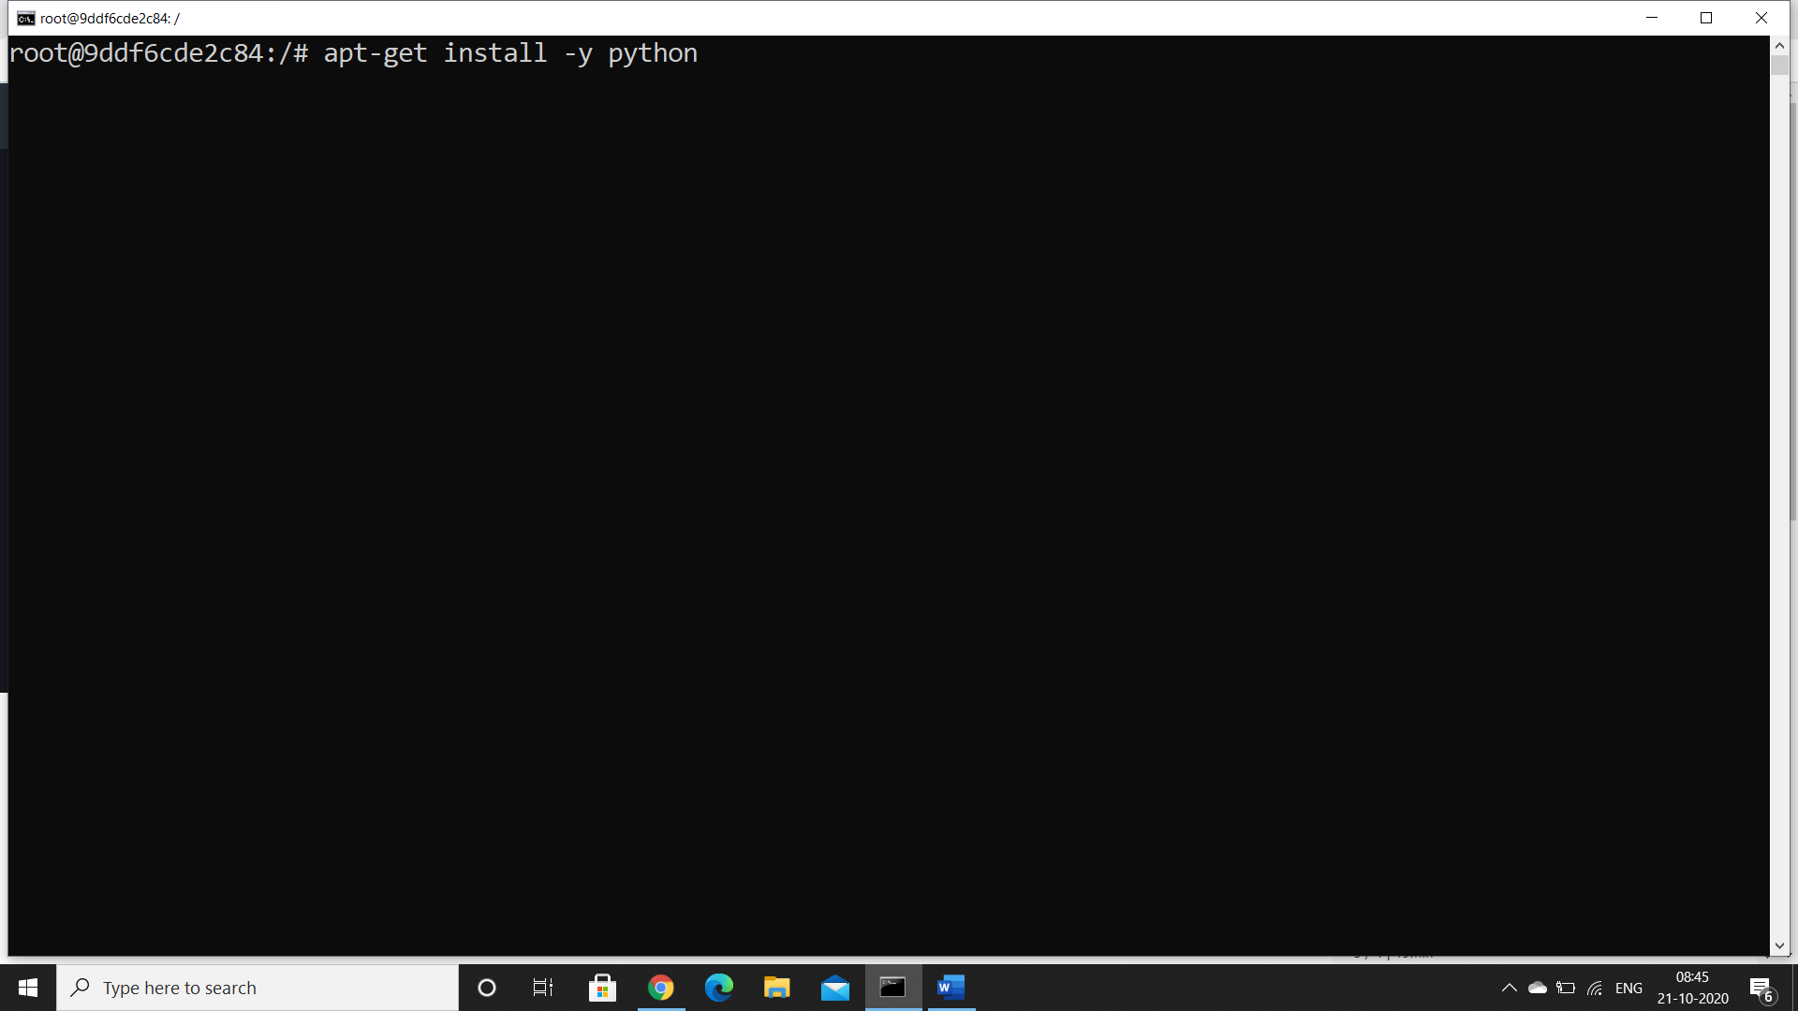

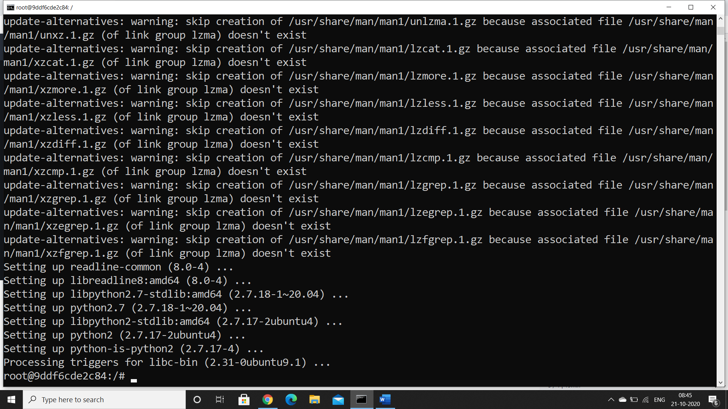

Verify python installed

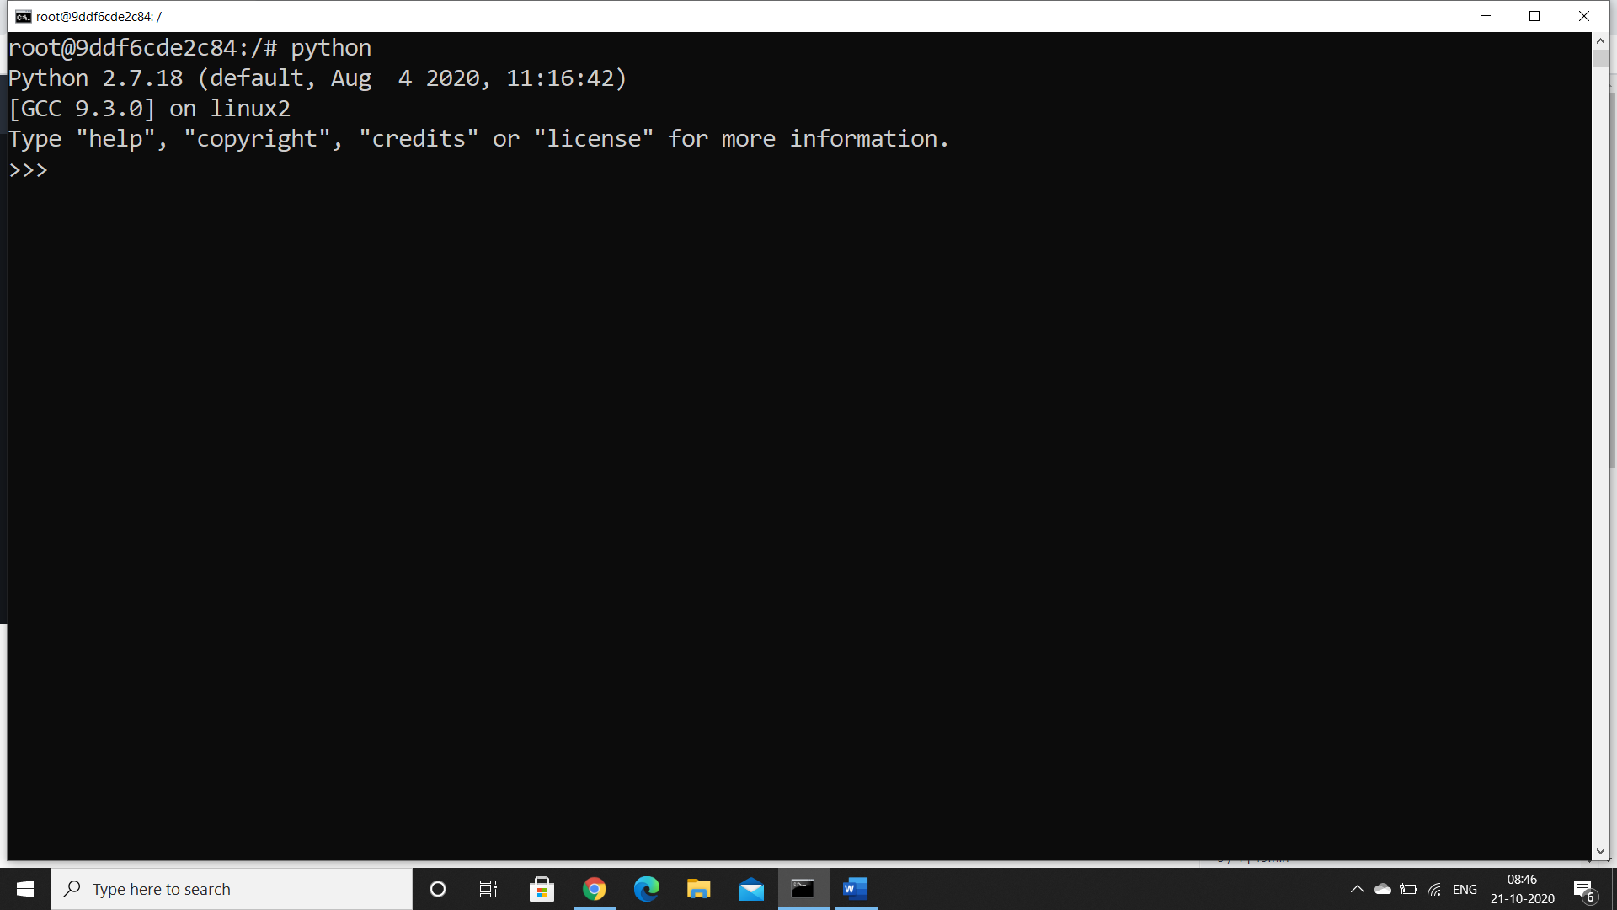

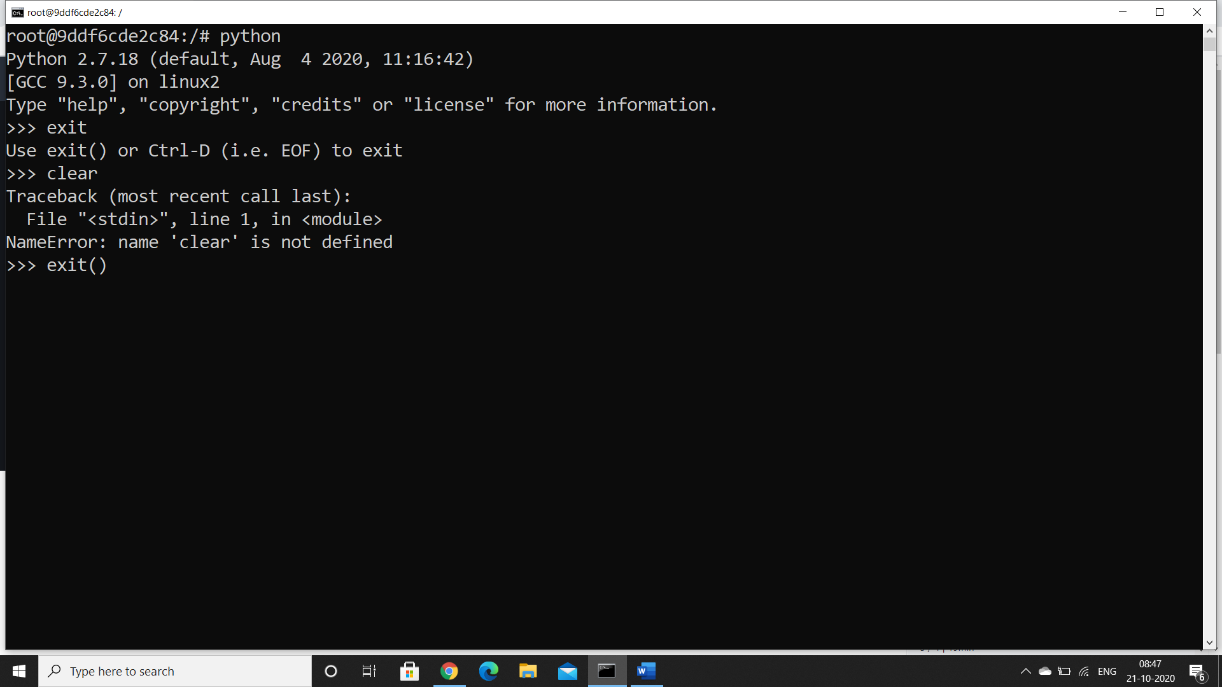

Install flask

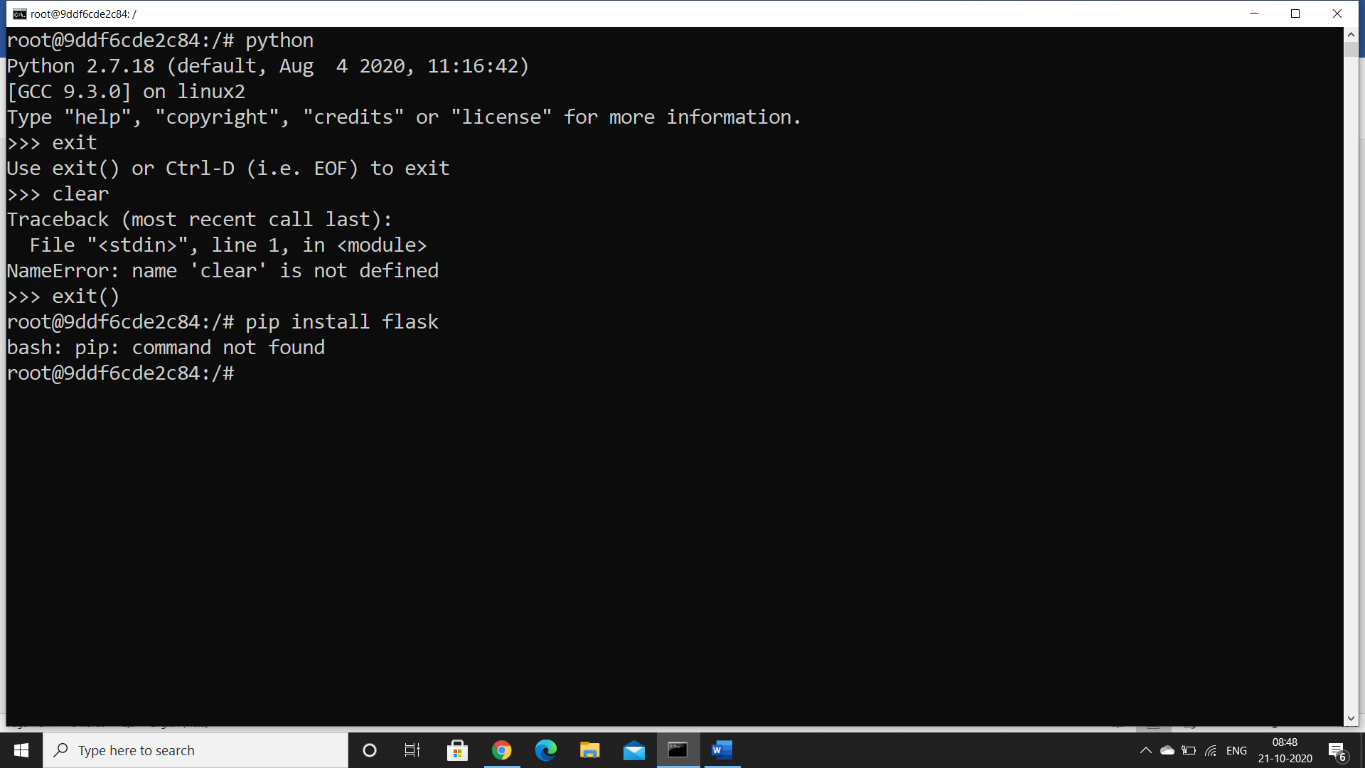

So first install pip

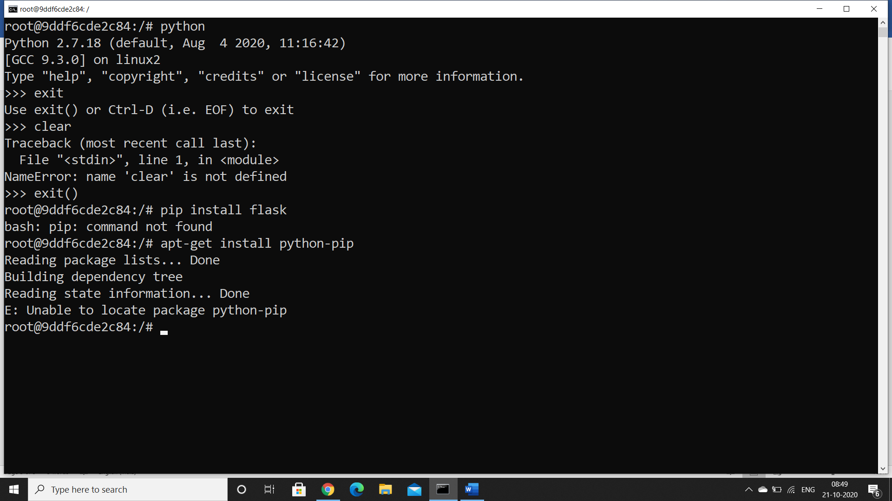

Then install flask

Apt-get install python3-pip

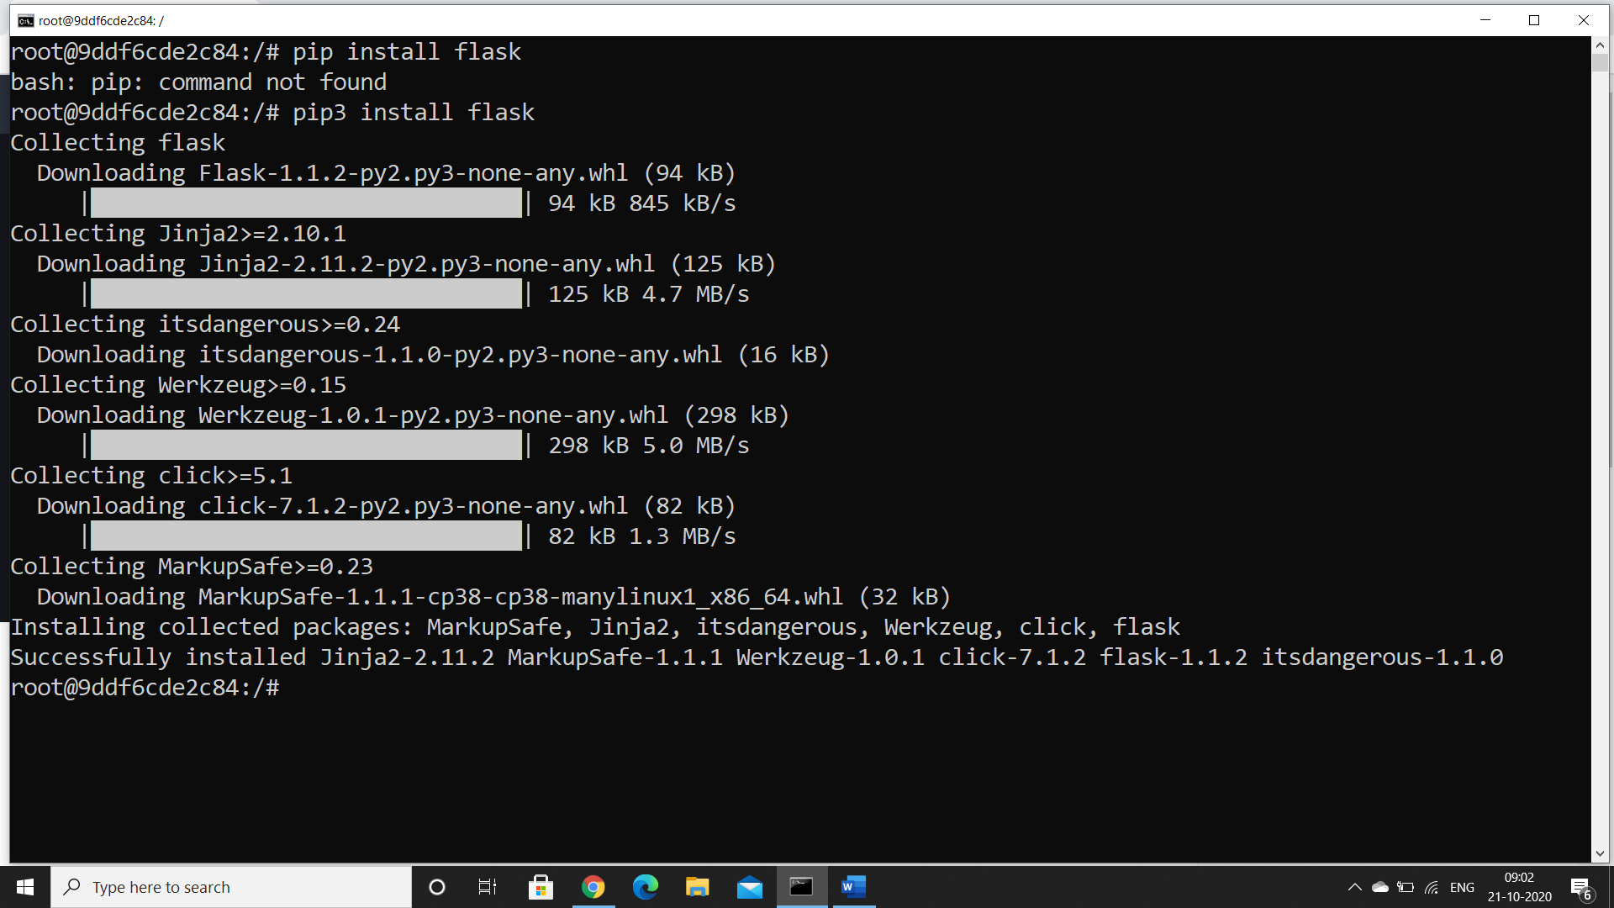

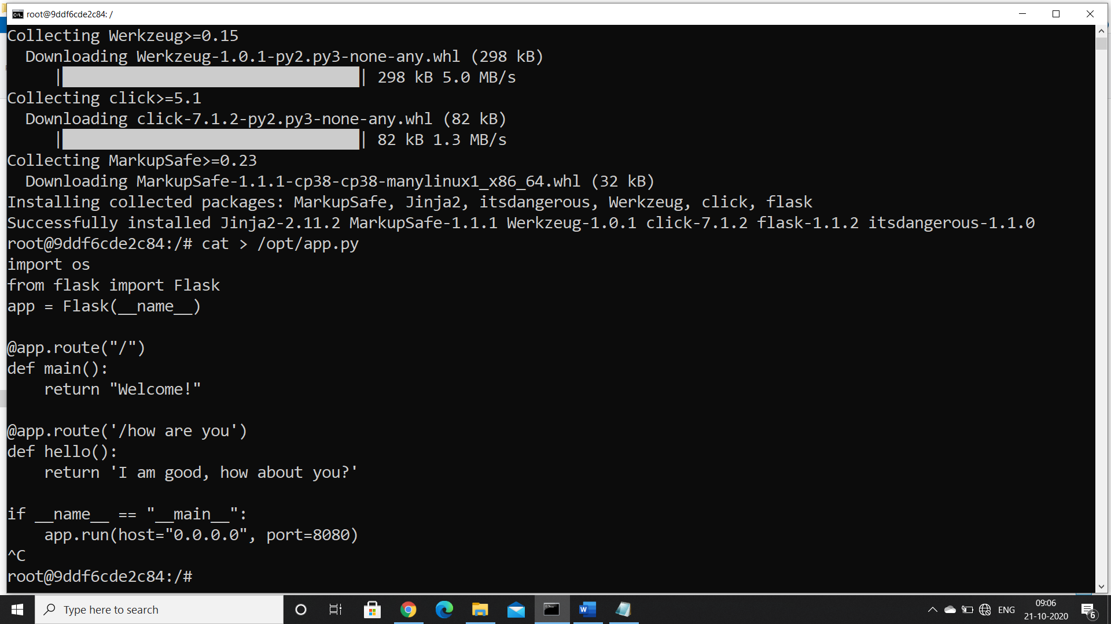

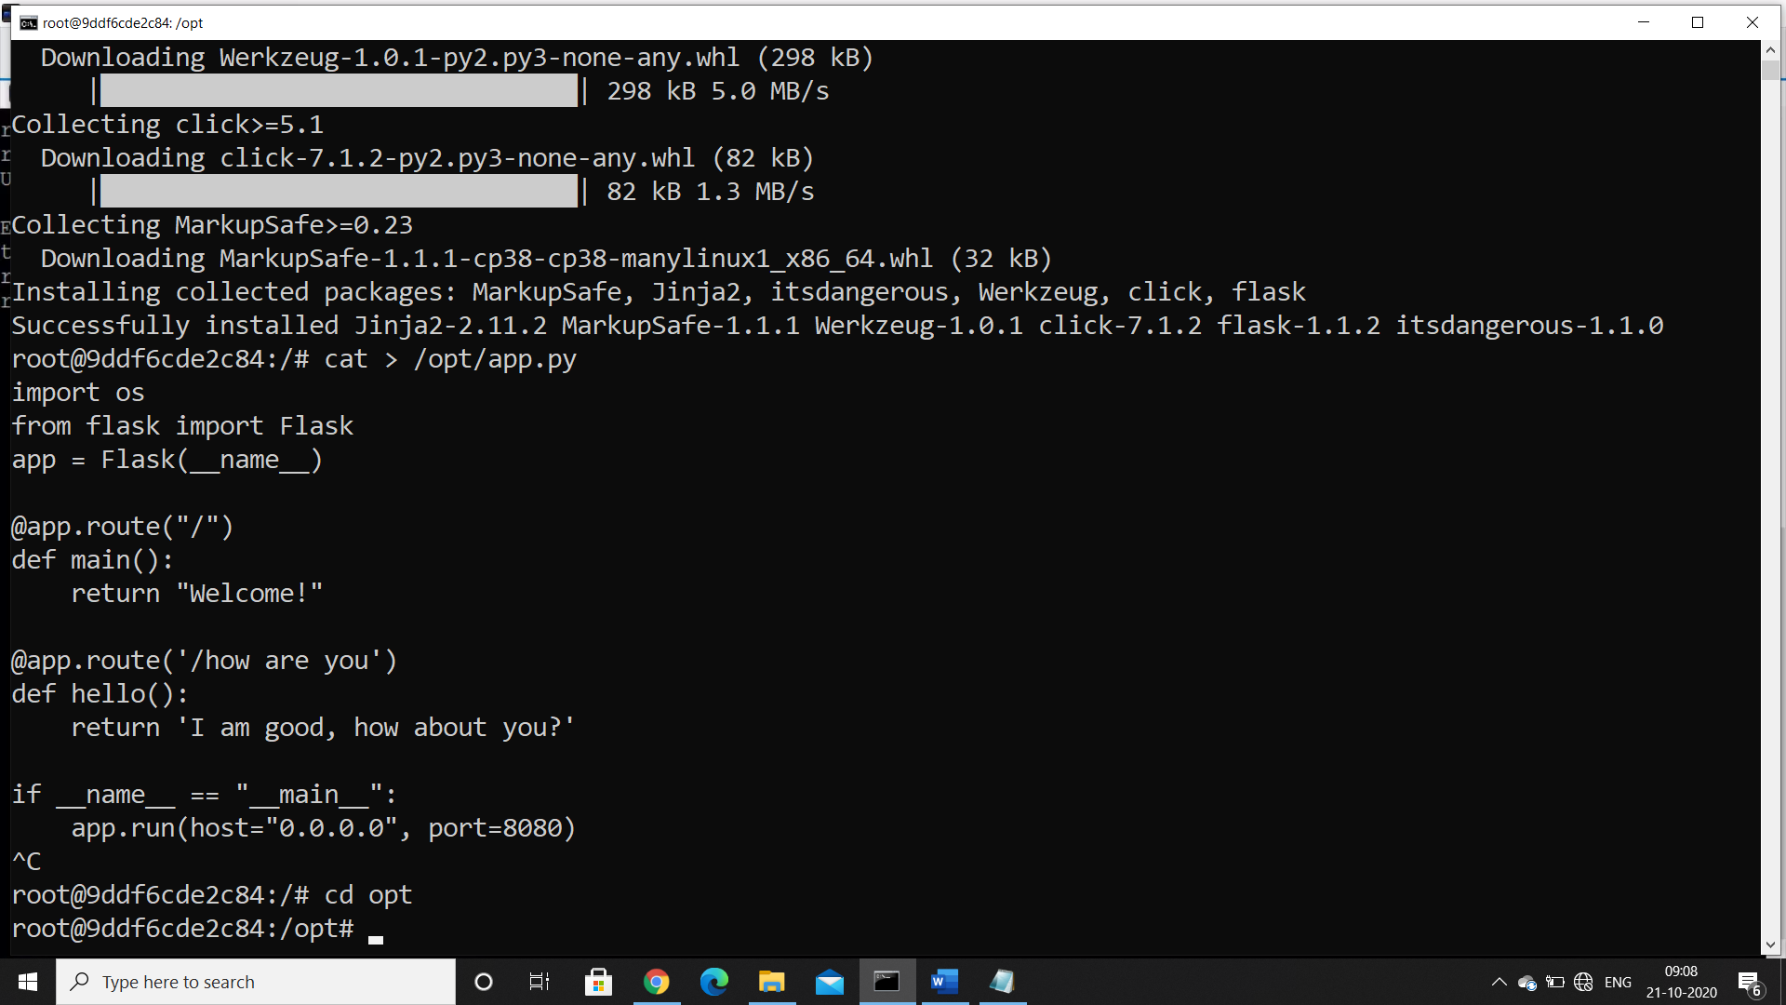

Now run simple history command and see all the commands we have typed till now

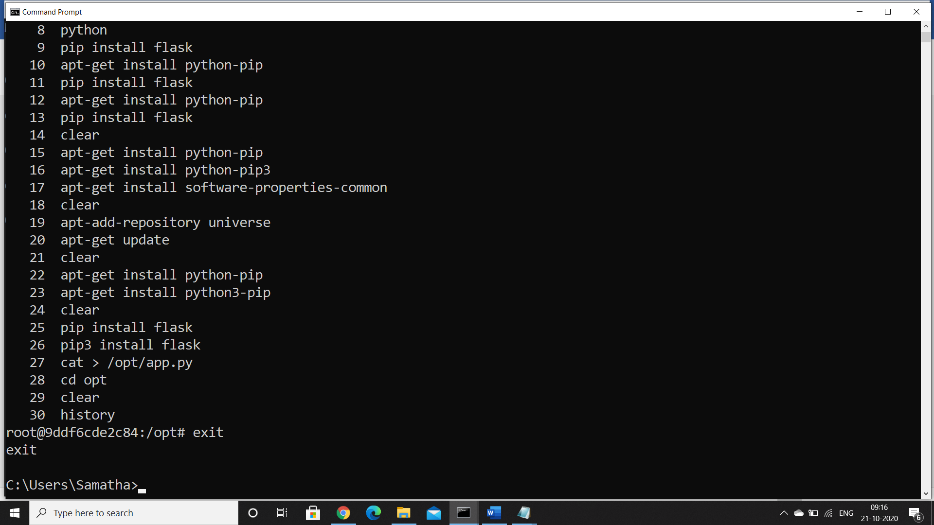

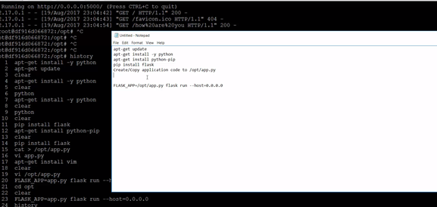

Come back to docker container

And create a directory

Mkdir my-simple-webapp

Cd my-simple-webapp

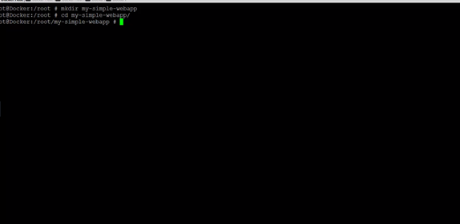

Create a Docker file within your directory

If you are working in Windows host

Then type the command as notedpad Dockerfile

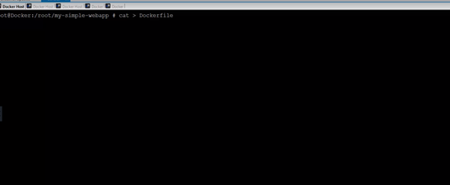

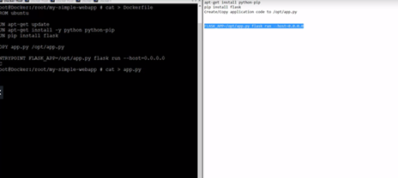

Copy all the commands which we have seen in history command in Dockerfile save and close

Create a app.py file and Copy the source code and exit the file

Build the docker file

1. Docker build .
2. Docker built . -t my-simple-webapp

Verify with

Docker images

Create conatiner using

Docker run my-simple-webapp

Inorder to push it into docker hub rebuild it with your dockerhubid and push it in hub

Docker Build . -t samatharamakrishna1976/my-simple-webapp

Docker push samatharamakrishna1976/my-simple-webapp

Connect to docker hub

Login and check the image